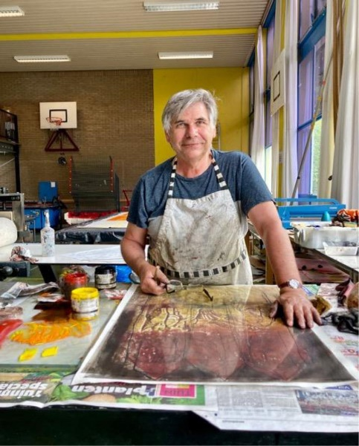 Foto: Geert Schriever Aga Lab Amsterdam

Curriculum Vitae
Wim van Broekhoven (1955 Dirksland)
www.grafiekdehendrick.nl
Hendrikstraat 47 3314 ZM Dordrecht Netherlands
Academy for Visual Education Tilburg
Academy of Visual Arts Willem de Kooning Rotterdam

Activities Education
Until 1/09/2019 Teacher Graphic Design/Art Grafisch Lyceum Rotterdam
Supervision of aspiring academy students in the development
of academy admission portfolios
Art Teacher Drawing and Painting Studio 76 Dordrecht
BigDraw Dordrecht
Workshops Outdoor Drawing Pictura 250 years Dordrecht
Project Ode to Willem Witsen Dordrecht

Activities Art and Recidences
Conceptcollaboration Konstmuseum Uppsala in Sweden Grafiska Sällskapet 2024
Until 2022 organizer Model Drawing Pictura Dordrecht
Work Residences Visual Arts Counter Dordrecht ( AGA Lab Amsterdam, I am not your Friend , I am not Your Enemy, Litho Basement Diepenheim

Awards and Nominations
Design and production of print for farewell gift to Council Members Municipality of Dordrecht
Nomination Dutch Graphic Art Award 2024
Nomination Design Medal Dordtse Synode

Publications
30 years German-Dutch Graphics Fair Borken Germany
Catalog Brandsanierung Leipzig Germany
Picturablad Dordrecht I am not your Friend I am not your Enemy
Figure Drawing Dordrechtpress
Grafiek Platform Bulletin
The Art of Drawing Diepenheim / Pictura Dordrecht
30-year Jubilee Edition Graphics Fair Borken German
30-Year Jubilee Edition Print Fair Borken Germany

Exhibitions
Participation in the German/Dutch Print Fair Borken Germany
City Museum Borken Germany
The Art of Drawing Diepenheim / Pictura Dordrecht
Month of the Print Pictura Dordrecht
Artists Draw the City City Archive Amsterdam
Participation in the Large Portraits Gallery Pictura Dordrecht
The Garden Garden Drawings Villa Augustus Dordrecht Albert Schweitzer Hospital Zwijndrecht
Printmanifestations Linge Art Overijssel/Groningen/Friesland
Topographical work included in the City Archives of Dordrecht, Delft, Rotterdam, and Amsterdam
Art Hollandaise Chamber Gallery Preporche France
Galerie Dulles Duisburg Germany
Artist in Residence AGA LAB Amsterdam
Art Eindhovengraphic Art Fair Abbey Middelburg
Brand Sanierung Weissenfels/ Leipzig Germany
De Prent Graphic Art Veldhoven
Begeestering Lithoproject Galerie Kempro Sterksel Eindhoven
Modeldrawing Galerie Nieuwstraat Dordrecht
I am not your Friend I am not your Enemy Pictura Dordrecht
Print Fair Bochum Germany

